
Laboratorium Dasar Teknik Elektro – STEI ITB
Nama Kuliah (Kode) : Praktikum Sistem Mikroprosesor (EL3112)
Tahun / Semester : 2026-2027 / Ganjil
Modul : 1
Nama Asisten / NIM :
Nama Praktikan/NIM : Muhammad Aqeel Ghani / 13224071
Tugas Pendahuluan
- Instalasi Arduino IDE
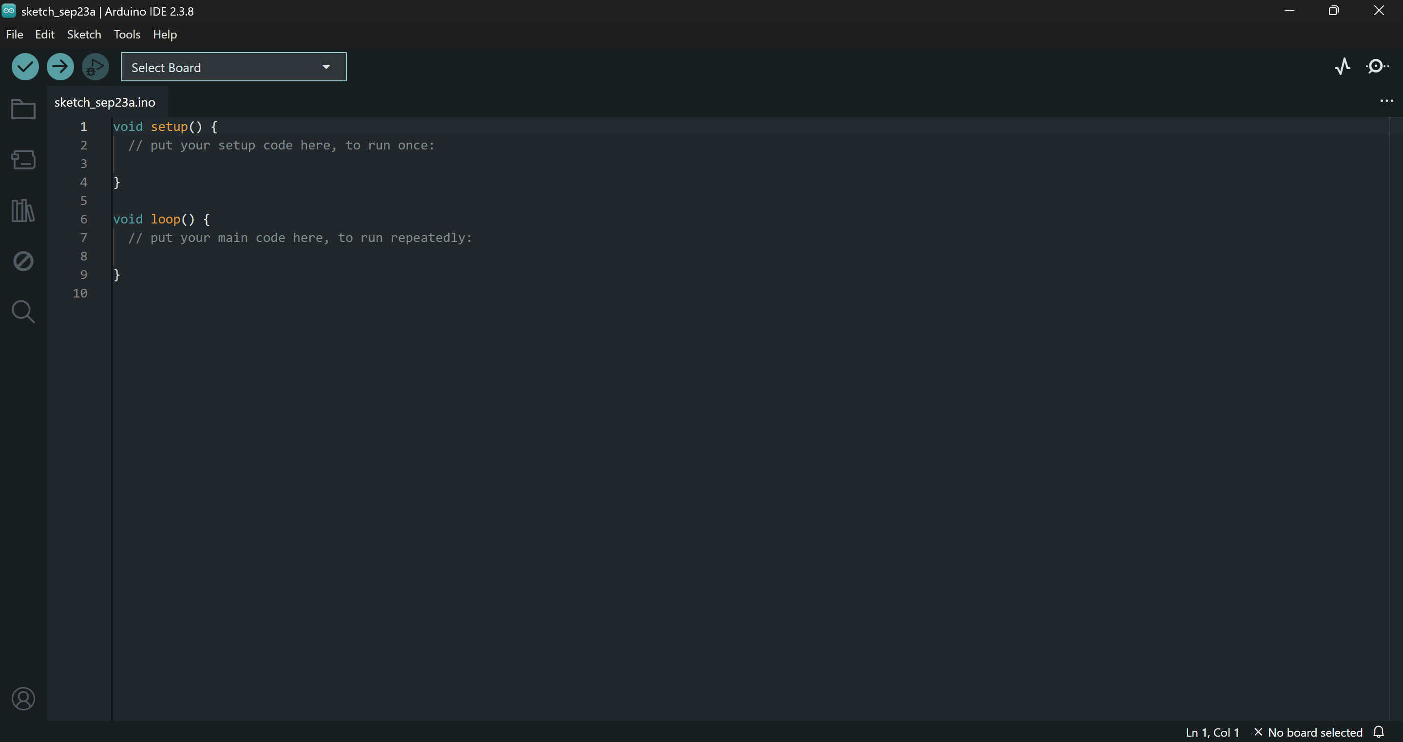
- Instalasi PlatformIO di Visual Studio Code
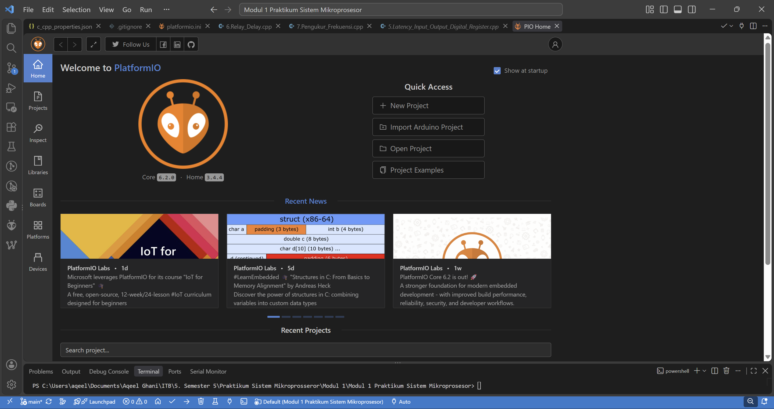
- Mencoba Compile contoh-contoh kode yang diberikan
- Output Digital dengan akses register ESP32
#include "soc/gpio_reg.h"
#include "driver/gpio.h"
#include <Arduino.h>

#define LED_PIN 2 // Built-in LED on most ESP32 boards
#define BLINK_DELAY_MS 500 // 500ms on + 500ms off = 1Hz
void setup() {
// Configure GPIO pin as output using register access
// Enable the GPIO pin in the output enable register
REG_WRITE(GPIO_ENABLE_REG, REG_READ(GPIO_ENABLE_REG) | (1 << LED_PIN));

// Set pin function to GPIO (not special function)
PIN_FUNC_SELECT(GPIO_PIN_MUX_REG[LED_PIN], PIN_FUNC_GPIO);

// // Optional: Set pin to push-pull mode (default, but explicit)
// REG_SET_BIT(GPIO_PIN_REG[LED_PIN], GPIO_PIN_PAD_DRIVER);

Serial.begin(115200);
Serial.println("ESP32 Register-based LED Blink Started");
}
void loop() {
// Turn LED ON - Set the bit high using register access
REG_WRITE(GPIO_OUT_REG, REG_READ(GPIO_OUT_REG) | (1 << LED_PIN));
Serial.println("LED ON");
delay(BLINK_DELAY_MS);

// Turn LED OFF - Clear the bit using register access
REG_WRITE(GPIO_OUT_REG, REG_READ(GPIO_OUT_REG) & ~(1 << LED_PIN));
Serial.println("LED OFF");
delay(BLINK_DELAY_MS);
}
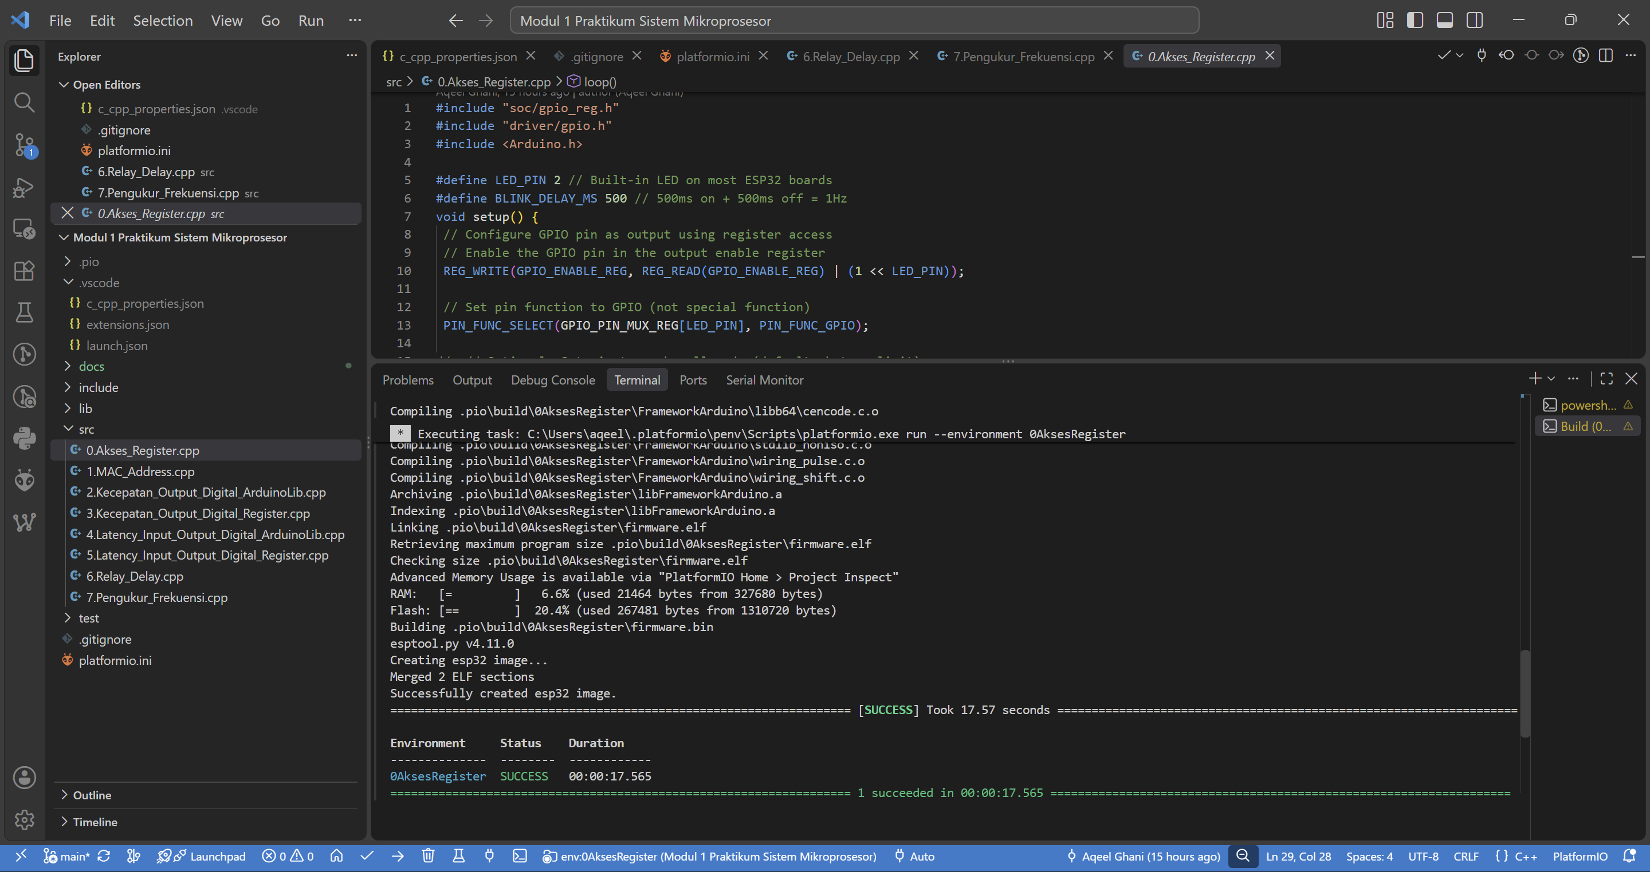
- Mencatat MAC Address (Identitas) ESP32
#include <WiFi.h>
#include <esp_wifi.h>

void readMacAddress(){
uint8_t baseMac[6];
esp_err_t ret = esp_wifi_get_mac(WIFI_IF_STA, baseMac);

if (ret == ESP_OK) {
Serial.printf("%02x:%02x:%02x:%02x:%02x:%02x\n",
baseMac[0], baseMac[1], baseMac[2],
baseMac[3], baseMac[4], baseMac[5]);
} else {
Serial.println("Failed to read MAC address");
}
}

void setup(){
Serial.begin(115200);
WiFi.mode(WIFI_STA);
Serial.print("[DEFAULT] ESP32 Board MAC Address: ");
readMacAddress();
}

void loop(){

}
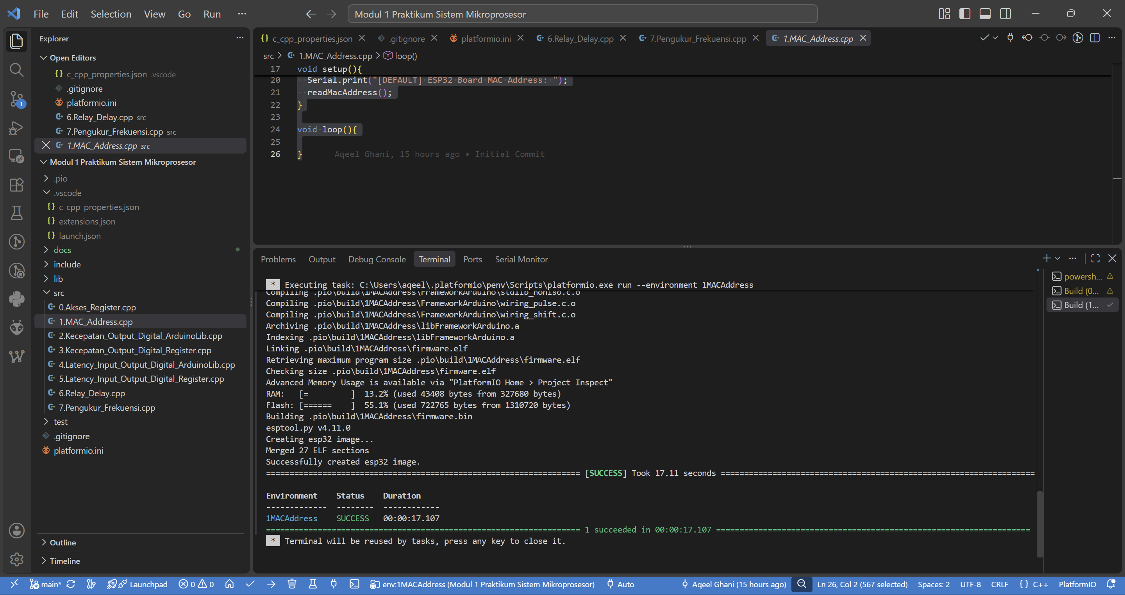
- Mengukur Kecepatan Output Digital dengan Library Arduino
#include <Arduino.h>

#define LED_PIN 22

void setup(){
pinMode(LED_PIN, OUTPUT);
}

void loop(){
digitalWrite(LED_PIN, HIGH);
digitalWrite(LED_PIN, LOW);
}
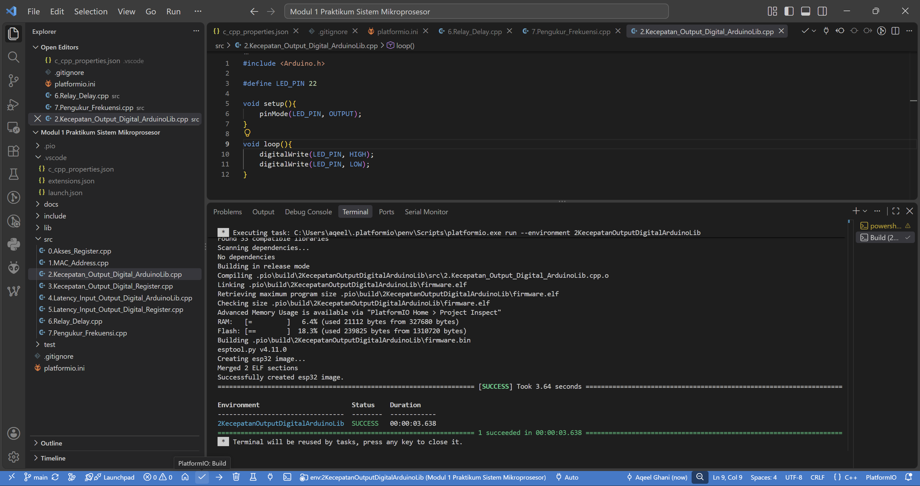
- Mengukur Kecepatan Output Digital dengan Akses Register
#include "soc/gpio_reg.h"
#include "driver/gpio.h"
#include <Arduino.h>

#define LED_PIN 22

void setup(){
pinMode(LED_PIN, OUTPUT);
Serial.begin(115200);
Serial.println("ESP32 Register-based LED Blink Started");
setCpuFrequencyMhz(240);
}

void loop(){
REG_WRITE(GPIO_OUT_REG, REG_READ(GPIO_OUT_REG) | (1 << LED_PIN));
REG_WRITE(GPIO_OUT_REG, REG_READ(GPIO_OUT_REG) & ~(1 << LED_PIN));
}
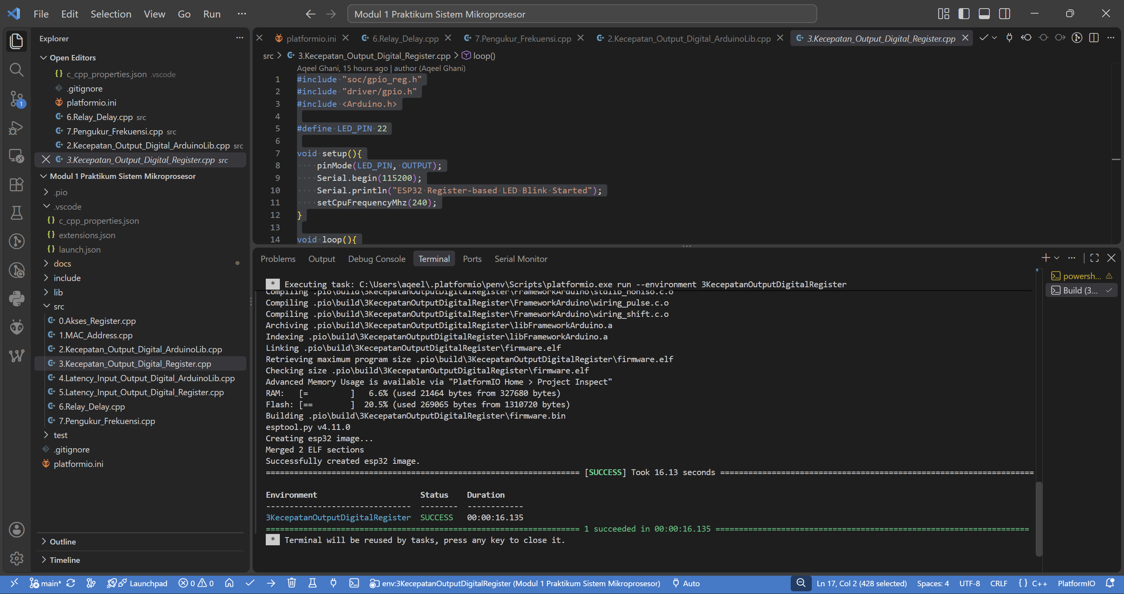
- Latency Input Output Digital dengan Library Arduino
#include <Arduino.h>

#define INPUT_1 25
#define OUTPUT_1 22

void setup(){
pinMode(INPUT_1, INPUT_PULLUP);
pinMode(OUTPUT_1, OUTPUT);
Serial.begin(115200);
Serial.println("ESP32 Started");
}

void loop(){
int input1, input2;
input1 = digitalRead(INPUT_1);
digitalWrite(OUTPUT_1, input1);
}
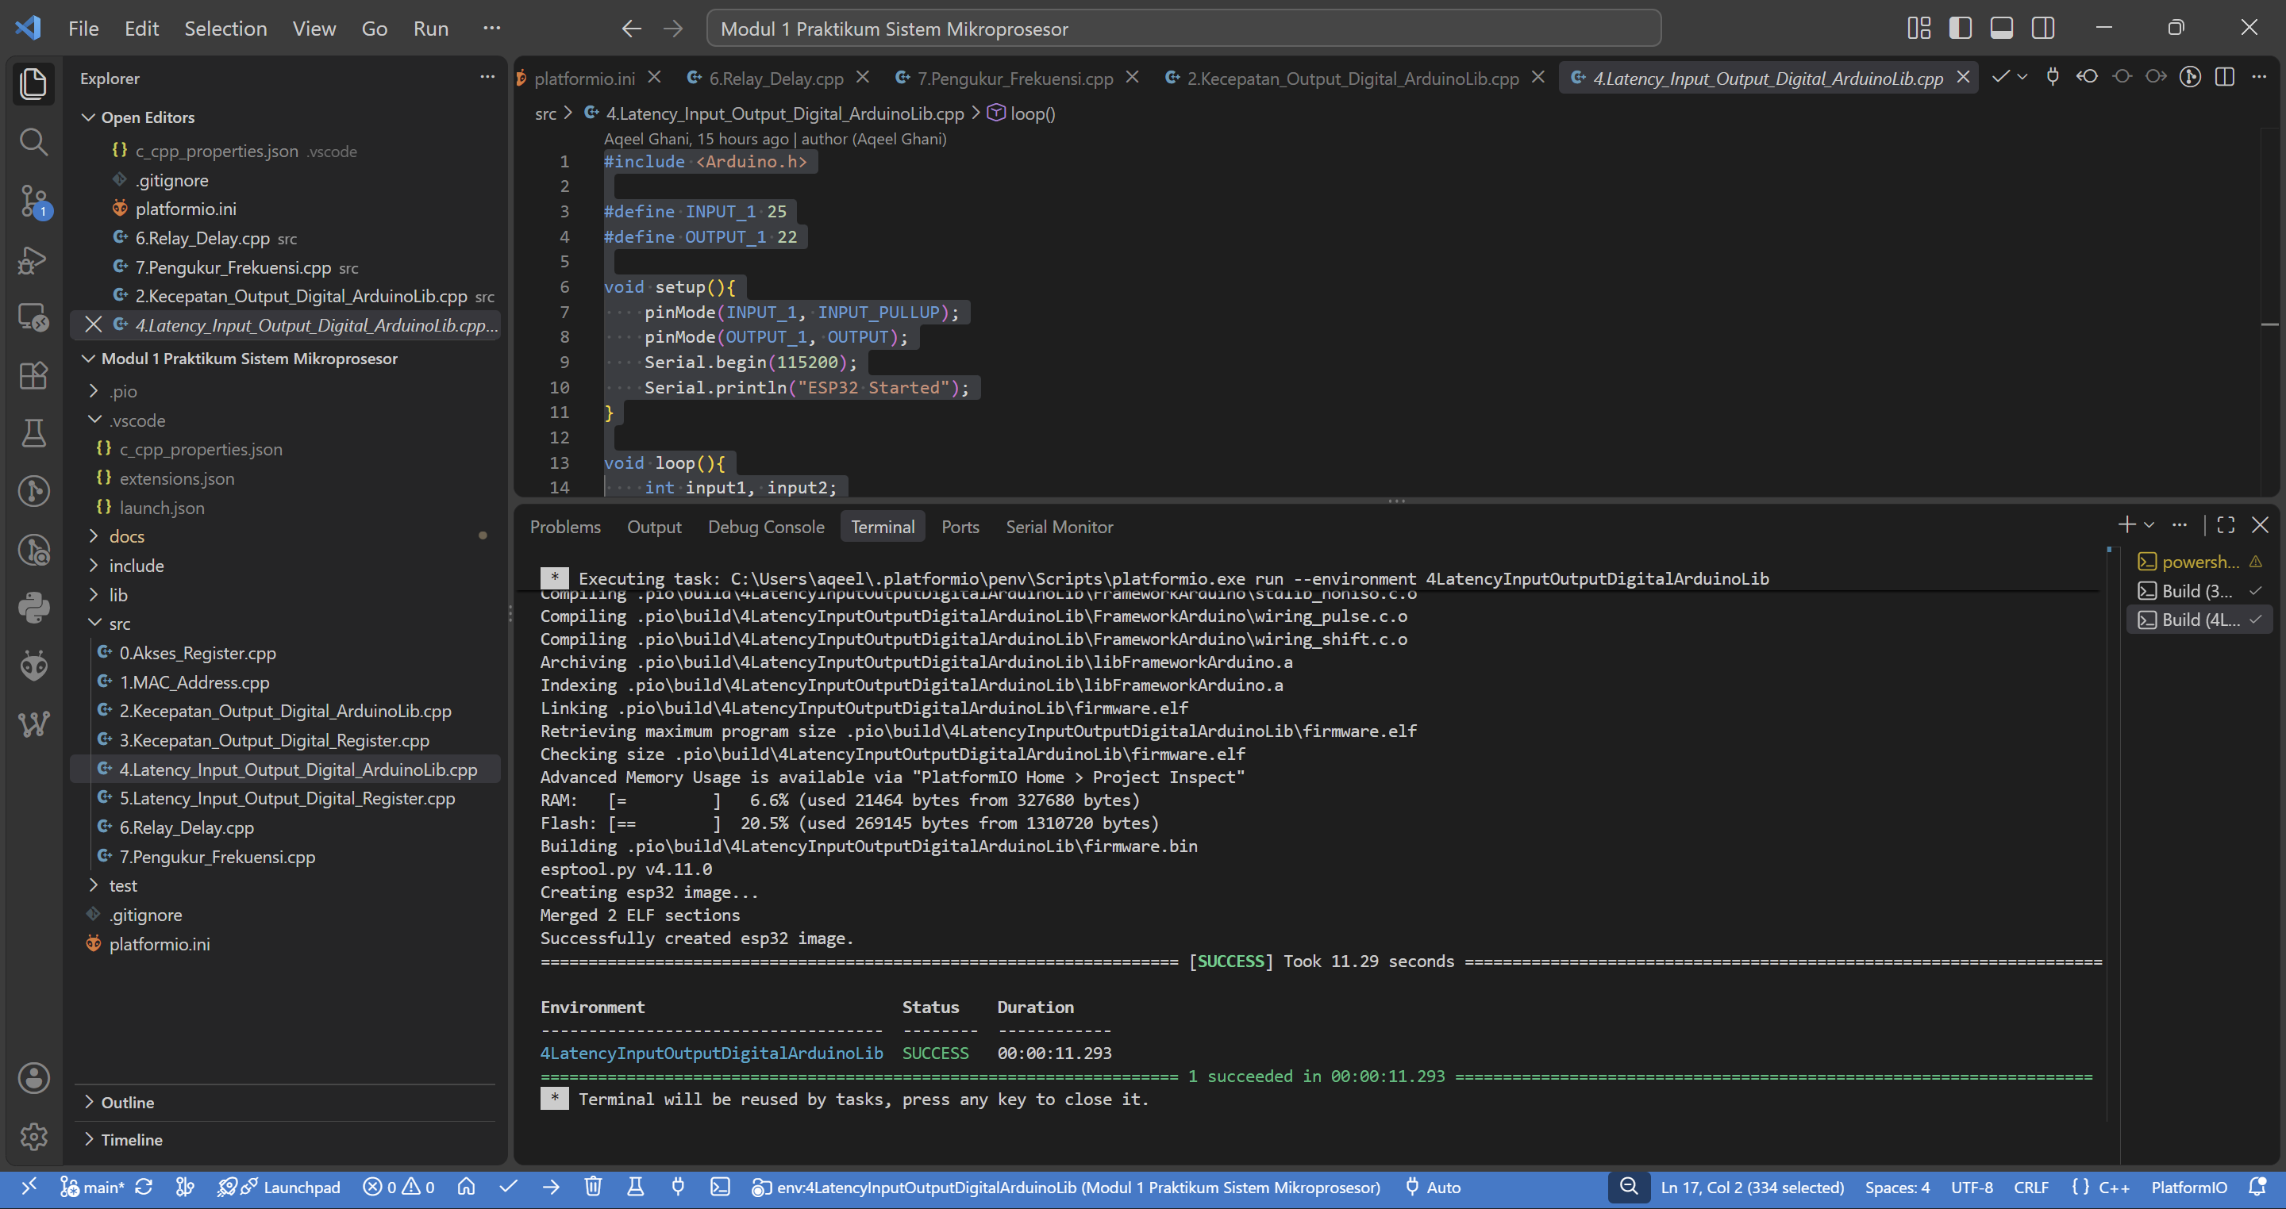
- Mempersiapkan tugas-tugas kode yang diberikan
- Latency Input Output Digital dengan Akses Register
#include <Arduino.h>
#include "soc/gpio_reg.h"
#include "driver/gpio.h"

#define INPUT_1 25
#define OUTPUT_1 22

void setup(){
pinMode(INPUT_1, INPUT_PULLUP);
REG_WRITE(GPIO_ENABLE_REG, REG_READ(GPIO_ENABLE_REG) | (1 << OUTPUT_1));
Serial.begin(115200);
Serial.println("ESP32 Started");
}

void loop() {
uint32_t gpio_in = REG_READ(GPIO_IN_REG);
bool input1 = (gpio_in >> INPUT_1) & 0x1;

if (input1) {
REG_WRITE(GPIO_OUT_REG, REG_READ(GPIO_OUT_REG) | (1 << OUTPUT_1));
} else {
REG_WRITE(GPIO_OUT_REG, REG_READ(GPIO_OUT_REG) & ~(1 << OUTPUT_1));
}
}
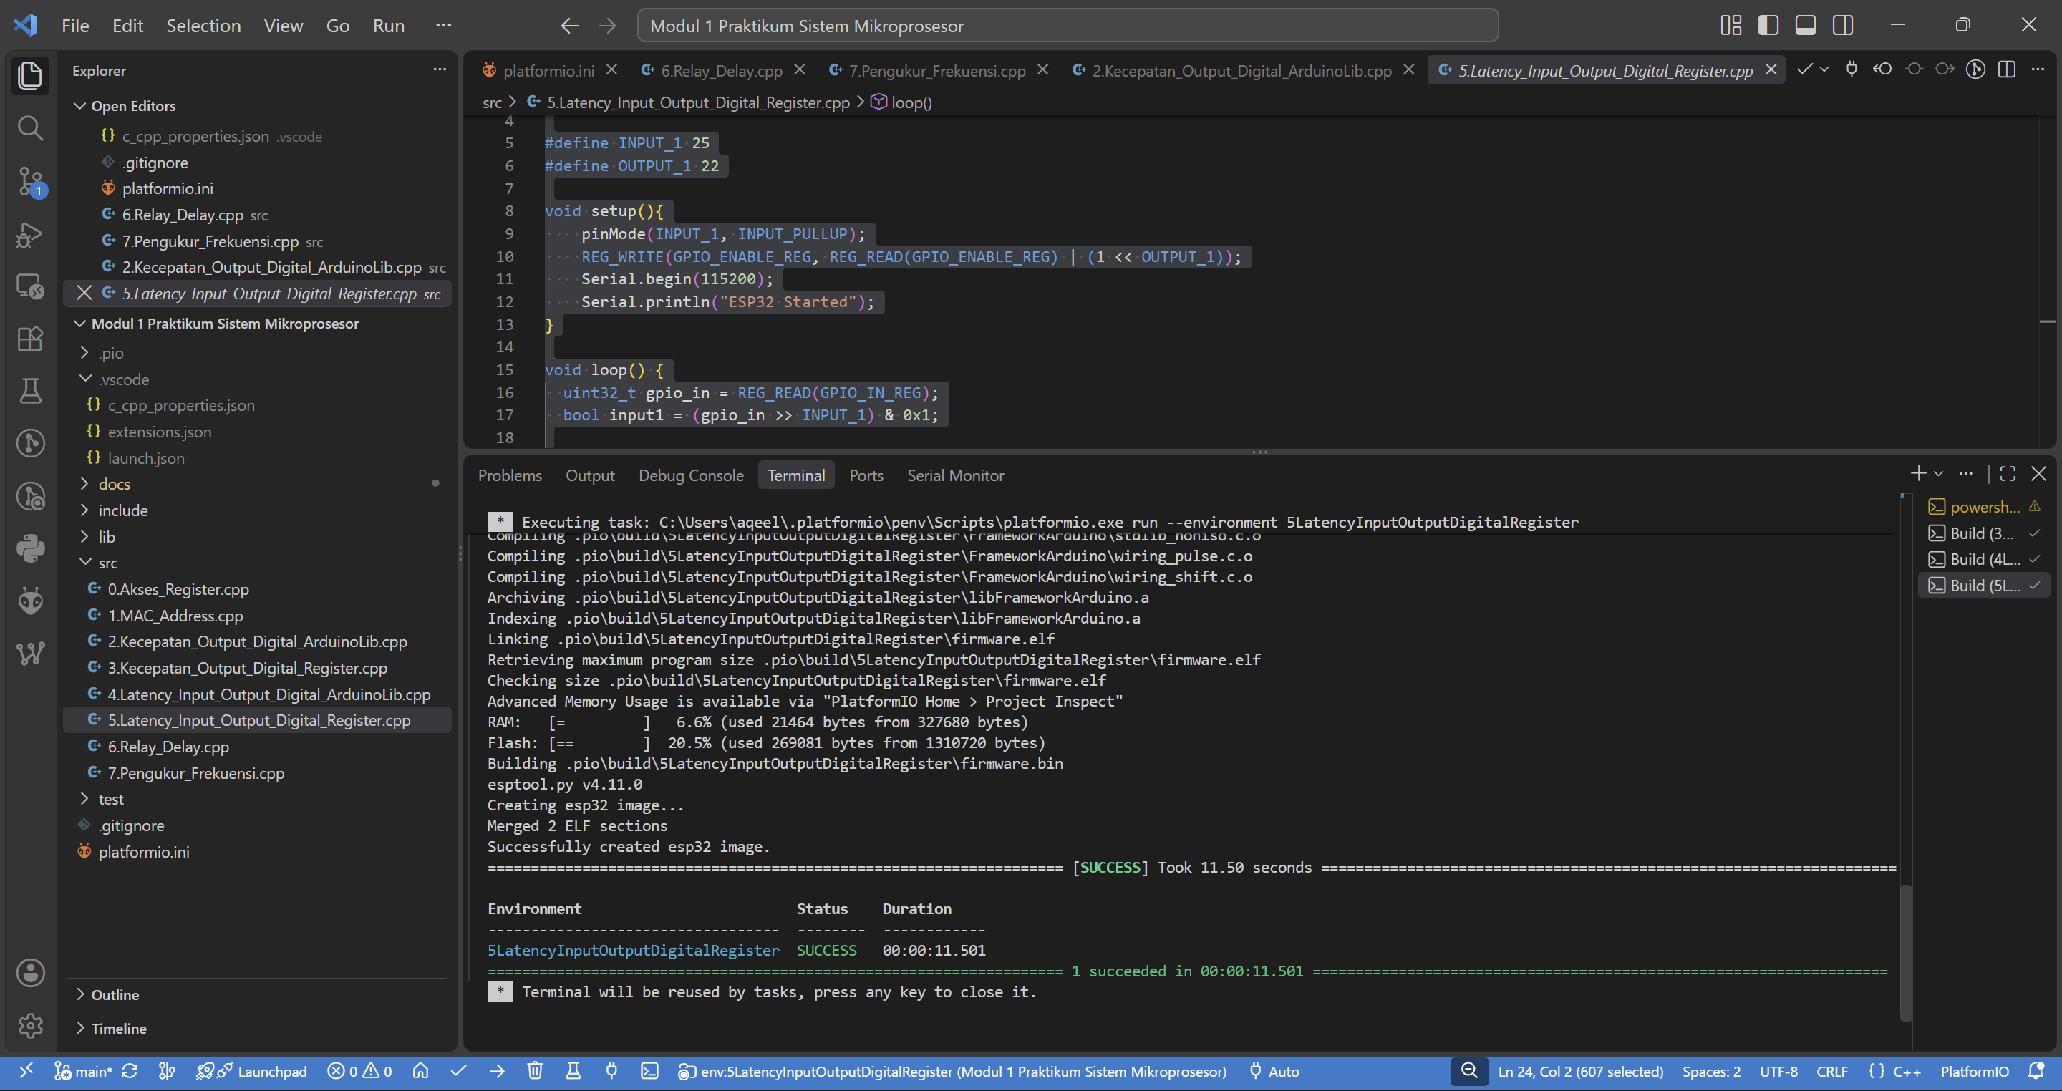
- Pengendali Relay
#include <Arduino.h>

#define Relay_Read 25
#define Relay_Write 22

unsigned long start_time = 0 , stop_time = 0;
unsigned short On=0;

void setup(){
pinMode(Relay_Read, INPUT_PULLUP);
pinMode(Relay_Write, OUTPUT);
Serial.begin(115200);
Serial.println("ESP32 Started");
}

void loop(){
if (On && digitalRead(Relay_Read)){
stop_time = millis();
Serial.print("Rising Delay : ");
Serial.print(stop_time-start_time);
Serial.println(" ms");
On = 0;
digitalWrite(Relay_Write, LOW);
start_time = millis();
} else if (!On && !digitalRead(Relay_Read)){
stop_time = millis();
Serial.print("Falling Delay : ");
Serial.print(stop_time-start_time);
Serial.println(" ms");
On = 1;
digitalWrite(Relay_Write, HIGH);
start_time = millis();
}
}
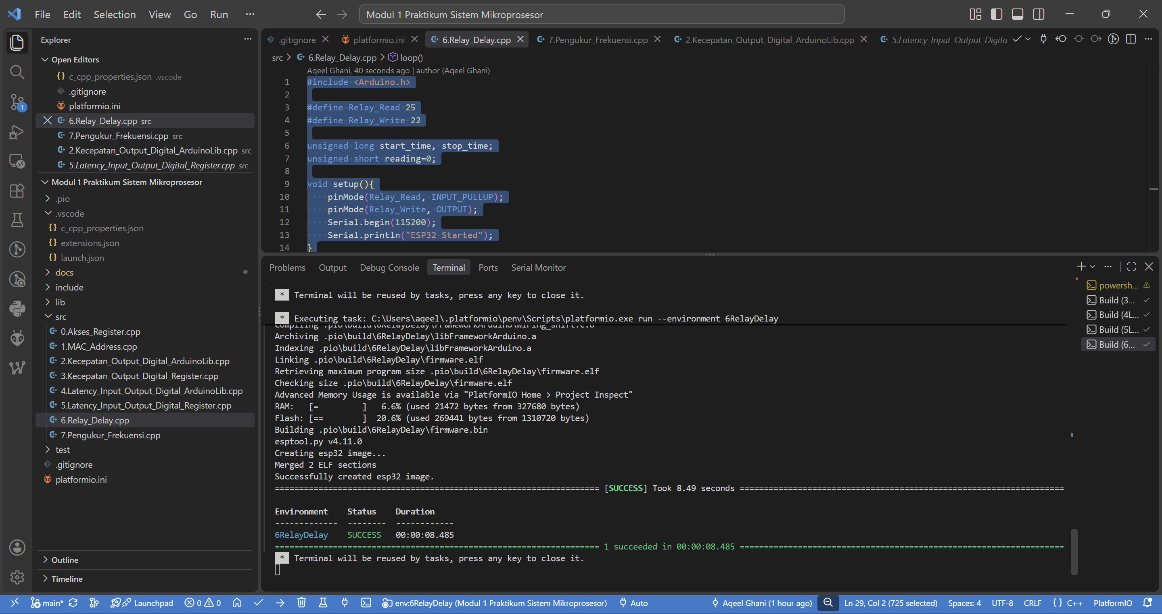
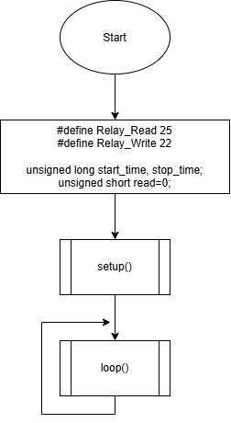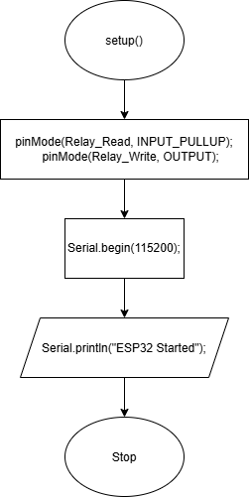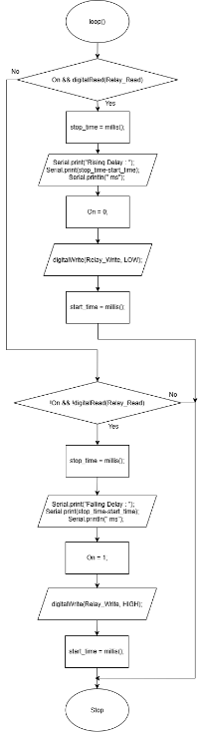
- Pengukur Frekuensi
#include <Arduino.h>

#define input1 25

int counter = 0;

void IRAM_ATTR count_interup();

void setup(){
pinMode(input1, INPUT);
Serial.begin(115200);
Serial.println("ESP32 Started");
attachInterrupt(digitalPinToInterrupt(input1), count_interup, RISING);
}

void loop(){
delay(1000);

Serial.print("Frekuensi ");
Serial.print(counter);
Serial.println("Hz");

counter = 0;
}

void IRAM_ATTR count_interup(){
counter++;
}
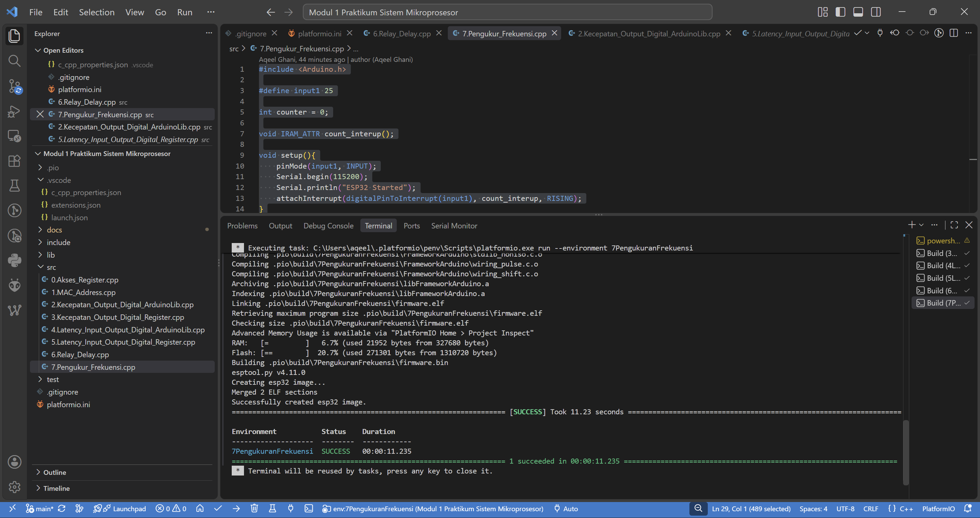
- Menyiapkan tabel-tabel pengukuran di setiap percobaan
